**Theory**

**Java** is a fully object-oriented program. It is a high level programming language. Java is a open-platform language that means a same program written in Java can be compiled in all the operating system (e.g. Windows, Mac OS, Linux) by the command prompt. Java is a full-featured general purpose programming language that is capable of developing robust mission critical applications. How to run java programs using *Command prompt* is given below:

**Printing “Hello World”**

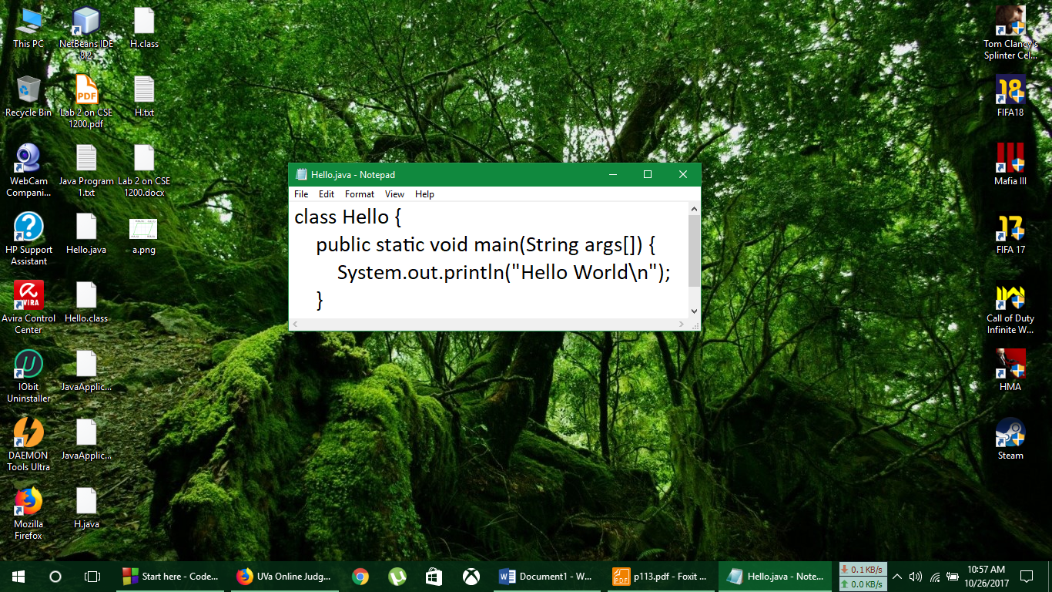

At first the ‘Notepad’ was opened and the above code was written and saved as Hello.java and then the command prompt was opened and the following steps was maintained.

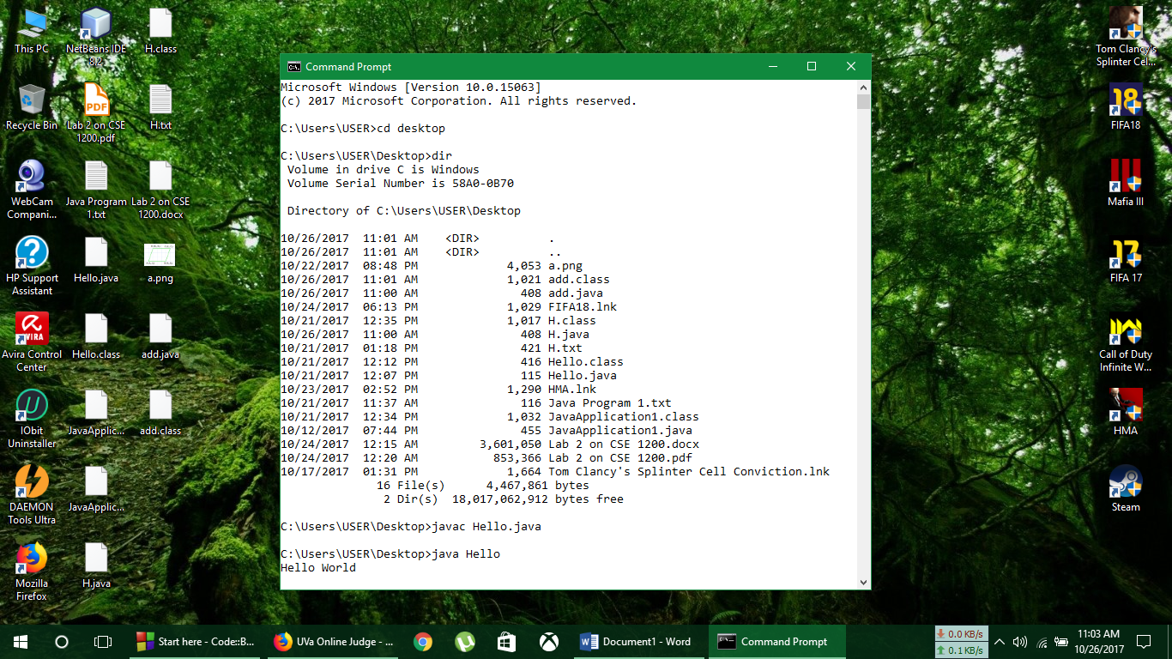

**Summation of two user given integer**

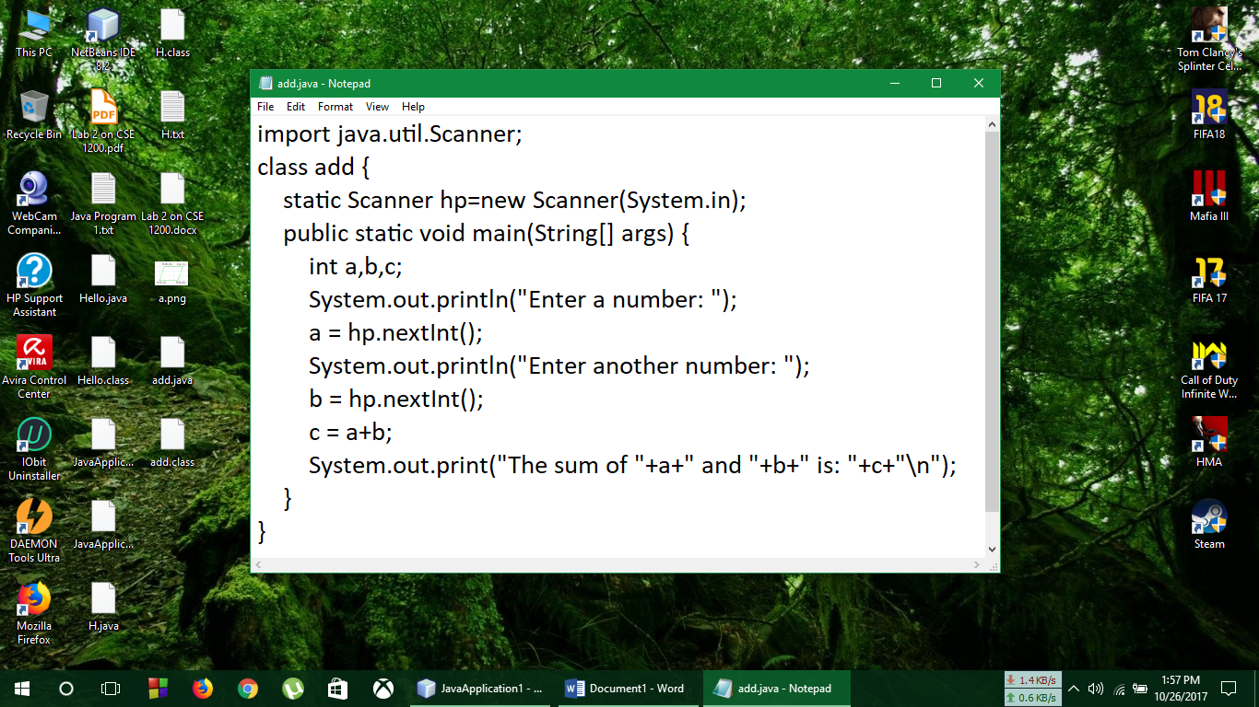

At first the ‘Notepad’ was opened and the above code was written and saved as add.java and then the command prompt was opened and the following steps was maintained.

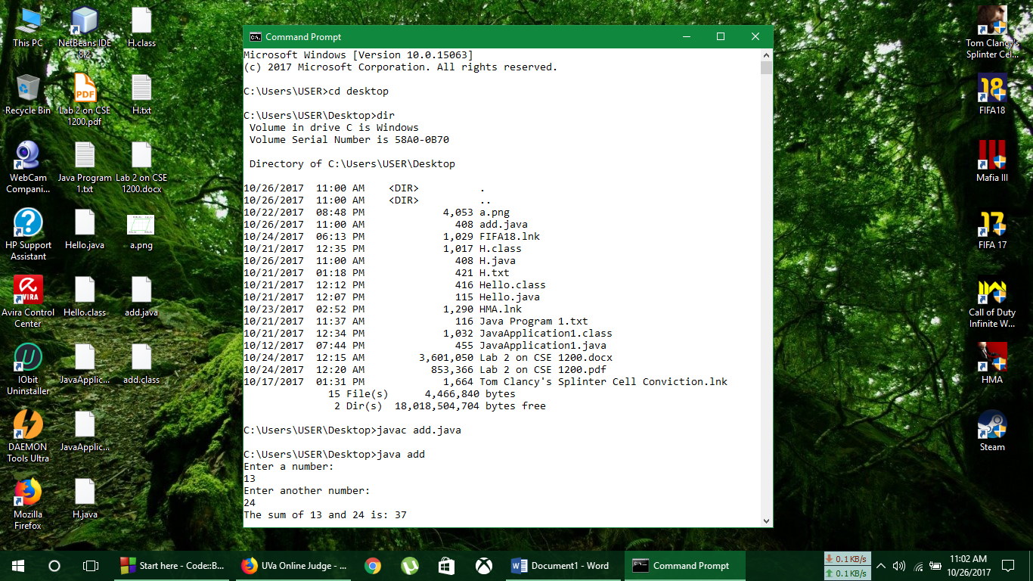

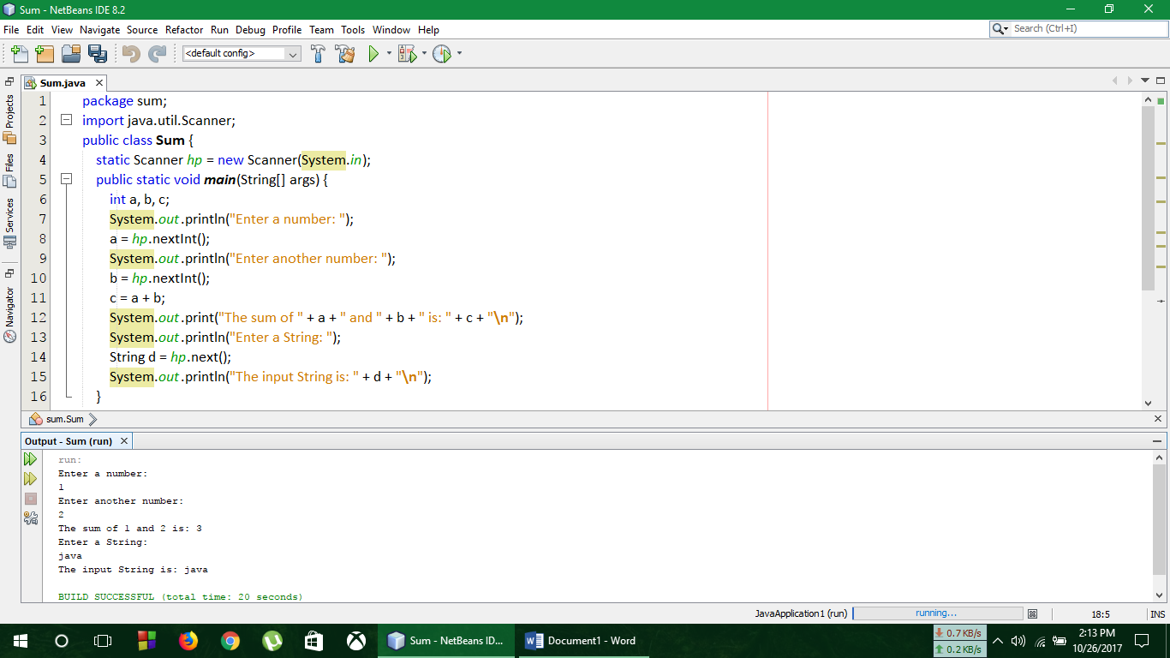**Adding two integers and string input by Java in Netbeans**